**What is Garbage collection in Java?**

Garbage collection in Java is the process by which Java programs perform automatic memory managemen (Deamon Thread)t. Java programs compile to bytecode that can be run on a Java Virtual Machine, or JVM for short. When Java programs run on the JVM, objects are created on the heap, which is a portion of memory dedicated to the program. Eventually, some objects will no longer be needed. The garbage collector finds these unused objects and deletes them to free up memory.

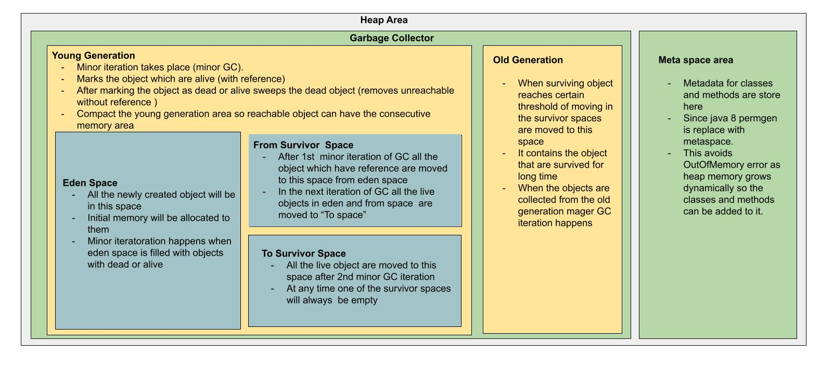

Types of GC collectors

1. **Serial GC** : It uses the only thread for garbage collection. It works by holding all the threads of an application. It means that threads of the application freeze by the serial garbage collector during the garbage collection process and the process is known as **stop the world** event.
2. **Parallel GC** : Multiple threads are used for minor GC in young generation and single thread is used for major GC in old generation. It also causes stop the world event and application freezes. This is the default GC type from java 5 to 8.
3. **Concurrent mark sweep :** multiple thread are used for minor and major GC along side application threads to minimize stope the world event. It uses more CPU than other GC types.
4. **G1GC :**
5. **Epsilon GC :**
6. **Shenandoah GC :**
7. **ZGC :**

